Foundation of xAI Gok

- What is Gok xAI?
It is a generative AI tool that uses a Large Language Model (LLM) to help users ask questions and find answers. It works similarly to a search engine, but the interaction is conversational, much like ChatGPT.

For example, you could ask:
“Please break down this user story into tasks.”
“Please recommend a daily meal plan within a $50 budget.”
Caution: Do not enter sensitive or confidential information when using Grok, as it may lead to unintended data exposure.
Grok is available both as a standalone application and within X (formerly Twitter).
- How can I use Grok?
You can go to www.grok.com
to start using Grok without creating an account.
However, if you want to program with the Grok API, you will need to create an account and generate an API key. Your application code will use this API key to access the Grok API.
If you plan to use Grok through X (formerly Twitter), it is recommended to use the Premium plan. For standalone use on www.grok.com
, the Basic plan may be sufficient.

- What else can I do with Grok.
- Attach files or images to a conversation. You can include documents, screenshots, or photos directly in the project conversation.
- Project organization: Capture pictures or attach files to keep all project-related information in one place.
- Schedule tasks: Grok can compile information and provide answers based on a set schedule. For example, you could schedule it to summarize today’s positive stock news at 6:00 AM, just before the market opens.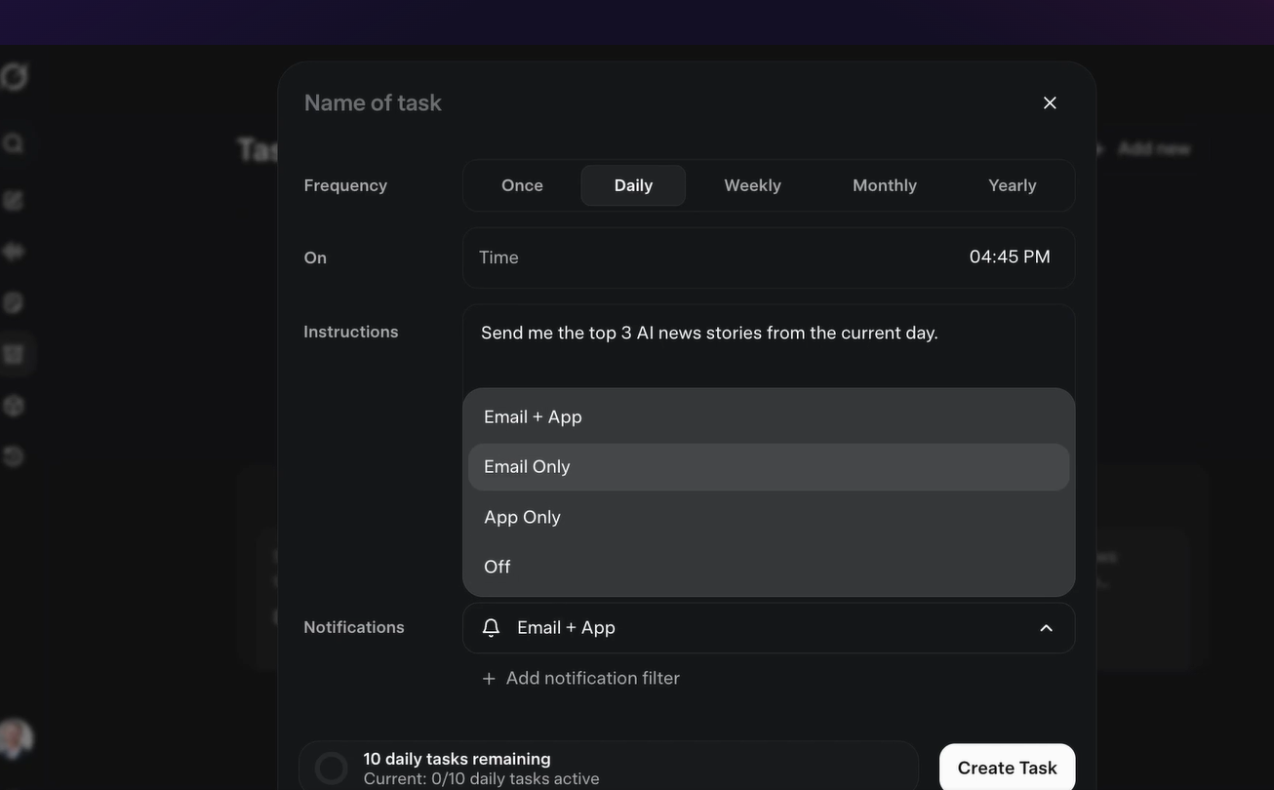

- Using Speaker to ask Grok the question by click on button below and start asking.
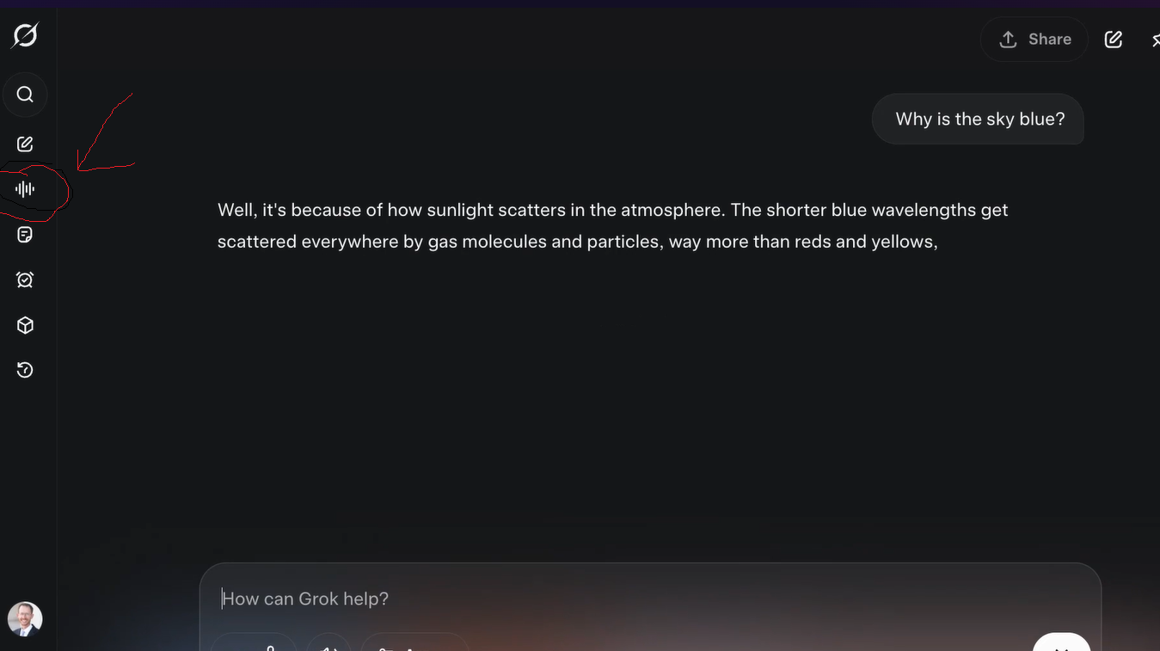

- Program application with Grok open AI.
Sign up account and request API key (Please see code project in the same directory of this repository)

- Course completion
https://app.pluralsight.com/ilx/video-courses/d1bcaceb-fe02-4c8c-ad04-5a21ffa9bcdd/160b35e1-eda0-4992-a99e-95d737a017a9/summary

